Experiment 14: Transformation using Homography Matrix
Software / Tools: Python · OpenCV (cv2) · NumPy

AIM
To compute a Homography matrix from point correspondences and use it to warp an image.
ALGORITHM
1. Import OpenCV and NumPy.
2. Read the input image and note its dimensions.
3. Define at least 4 source points and their corresponding destination points.
4. Compute the homography matrix using cv2.findHomography(pts_src, pts_dst).
5. Apply the homography with cv2.warpPerspective().
6. Display and save the transformed image.
PROGRAM (SOURCE CODE)
import cv2
import numpy as np

img = cv2.imread("image.jpg")
(h, w) = img.shape[:2]

pts_src = np.array([[0, 0], [w-1, 0], [w-1, h-1], [0, h-1]])
pts_dst = np.array([[50, 50], [w-100, 30], [w-50, h-60], [80, h-40]])

H, status = cv2.findHomography(pts_src, pts_dst)
homography_result = cv2.warpPerspective(img, H, (w, h))

cv2.imshow("Original", img)
cv2.imshow("Homography Transformed", homography_result)
cv2.waitKey(0)
cv2.destroyAllWindows()

OUTPUT
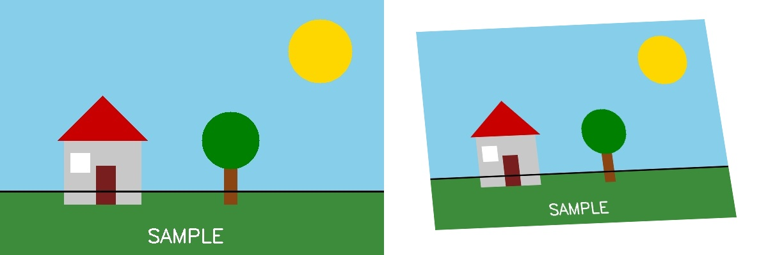
Fig. 14 — Output of Experiment 14: Transformation using Homography Matrix.
RESULT
Compute a Homography matrix from point correspondences and use it to warp an image — completed successfully, as demonstrated in the output shown above.

